A printed out as a CSV file (k1)

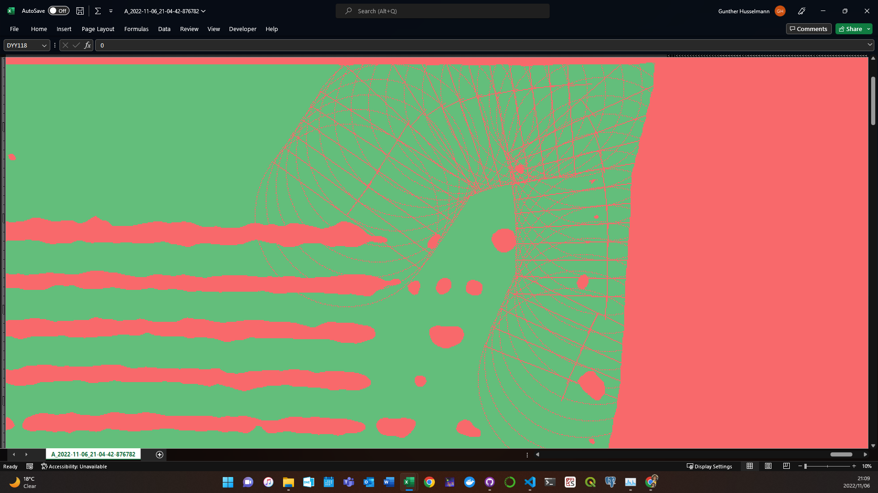

A_slime printed out as a CSV

